Linux

Introduction of Linux

- Linux was created by linus Torvalds in 1991
- It is open source operating system and secure operating system

Linux system architecture

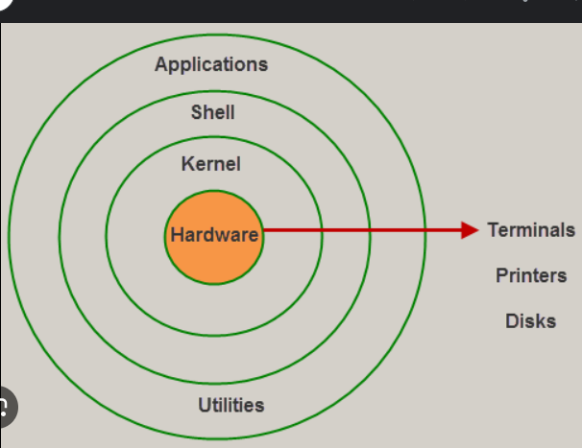

Hardware
- It is the Physical Component of linux
- Moniter,CPU,Hard disk etc…

Kernal
- It is the core component of linux
- It acts as the brain of linux os

Shell
- It is the interface of the kernal and it is also a software
- It takes command for the user and interprets them (ie binary to human’s language)

Commands in linux
- To create directory - mkdir (directory name)

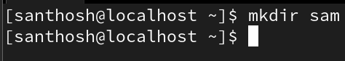

- To verify (list) the directory or file-ls

- To change directory from one to another -cd

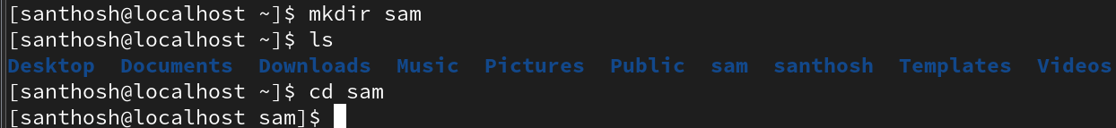

- To know the present working directory -pwd

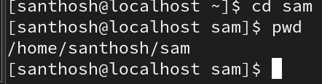

- To create file -touch file name

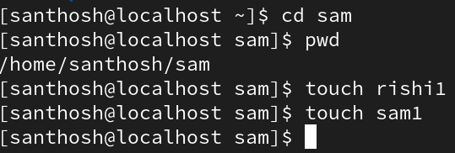

- To delete file -rm

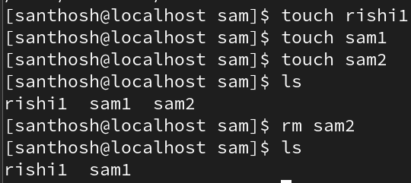

- To move to previous directoty -cd ..

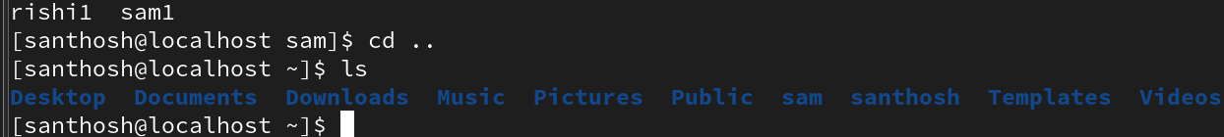

Change to Previous Directory:
Moves up one level in the directory hierarchy, to the parent directory.
Syntax:
#cd ..
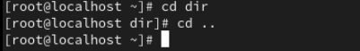
Change to Current Directory:
Syntax:
#cd .
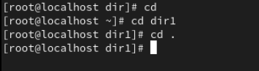
Change to Root Directory:
Returns to the user's home directory.
Syntax:
#cd
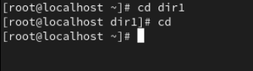
Present working directory:
The pwd command in Linux stands for "print working directory." Its primary function is to display the full path of the current directory you are currently located in within the file system.
Syntax:
#pwd
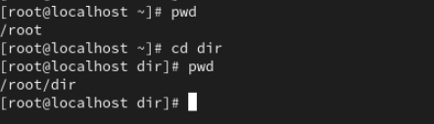
Create an empty file:
If a specified file does not exist, ”touch” command will create a new, empty file with that name.
Syntax:
#touch file_name
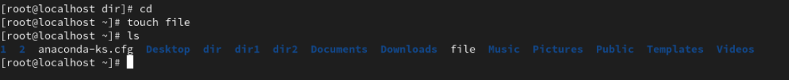
Create a multiple files:
You can create files with a numerical sequence in their names, for instance, file1, file2, etc., using brace expansion with a range.

Syntax:
#touch file_name{1..n}

Create a multiple directories:
You can create directories with a numerical sequence in their names, for instance, dir1, dir2, etc., using brace expansion with a range.
Syntax:
#mkdir dir_name{1..n}
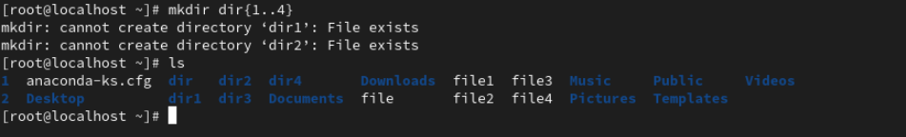
ls commands:
Show a detailed listing of files:
The ls -l command in Linux is used to display a detailed listing of files and directories within a given directory.
Syntax:
#ls -l
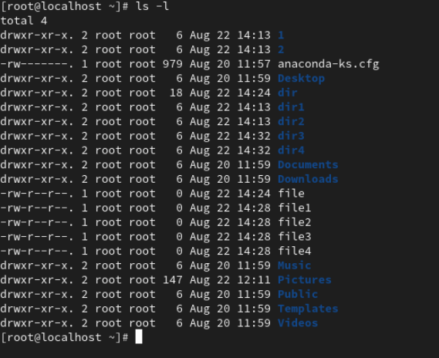
Detailed listing of Particular file:
Syntax:
#ls -l file_name
Detailed listing of Particular directory:
Syntax:
#ls -l dir_name
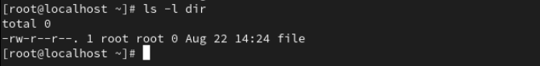
- r: Read permission is granted.
- w: Write permission is granted.
- 1: This number indicates the number of hard links to the file.
- root root: These indicate the owner and the group owner of the file. In this case, both the owner and the group owner are 'root'.
- 0: This represents the size of the file in bytes. Here, the file size is 0 bytes, meaning it's an empty file.
- Aug 22 14:28: This is the timestamp indicating the last modification time (mtime) of the file.
- file1: This is the name of the file.
Show all Hidden long listing files/directories:
The ls -a command in Linux is used to list all files and directories, including hidden files (those whose names begin with a dot).
Syntax:
#ls -a
Omitting . , .. files:
Syntax:
#ls -A
Show long listing files based timing:
The ls -lt command in Linux is used to display the contents of a directory in a detailed or "long" format, sorted by the last modification time, with the most recently modified files and directories appearing first.
Syntax:
#ls -lt
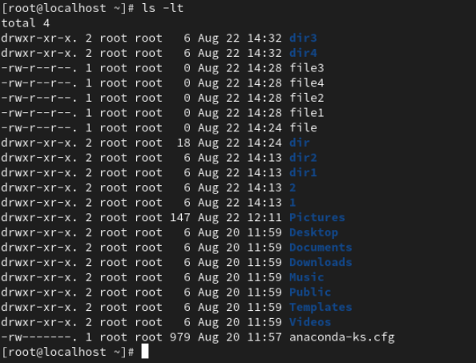
Show long listing files based sizes:
The ls -lS command in Linux is used to list the contents of a directory in a long format and sort them by file size, with the largest files appearing first.
Syntax:
#ls -lS
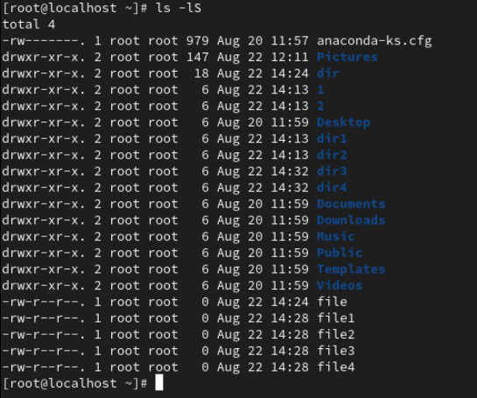
Reverse the long listing files:
Syntax:
#ls -lr
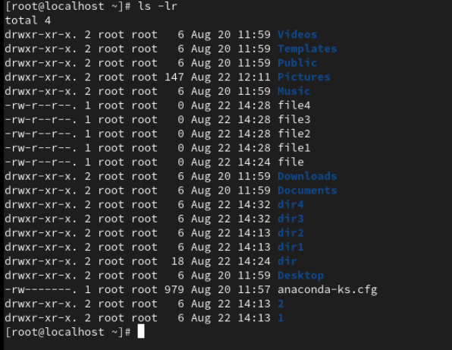
Show the files by time with reverse order:
The ls -ltr command in Linux is used to display the contents of a directory in a specific format, sorted by time, and in reverse order.
Syntax:
#ls -ltr
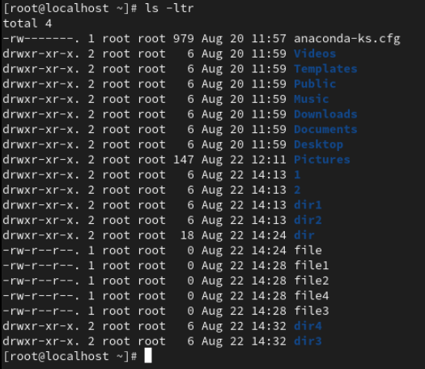

Show the files by Sizes with reverse order:
The ls -lSr command in Linux is used to display the contents of a directory in a specific format, sorted by size, and in reverse order.
Syntax:
#ls -lSr
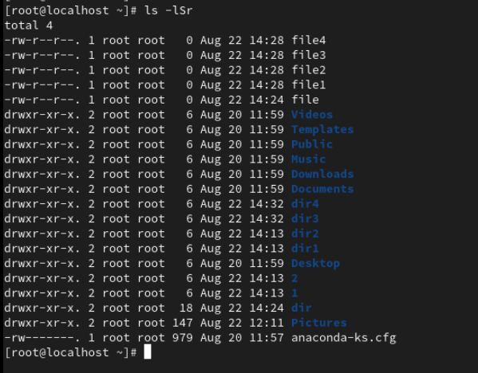
Show the particular present file/directory:
The ls -d command treats the directory as a file itself and displays details about it.
Syntax:
#ls -d
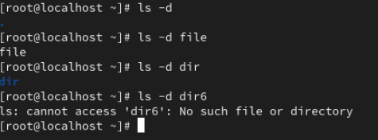

Syntax:
#ls -ld file_name
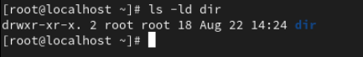
Indicate inode numbers:
The ls -i command in Linux displays the inode number of files and directories.
What is an Inode?
Inodes (index nodes) are data structures that store metadata about files and directories in a Linux. Inodes are unique identifiers for each file or directory.
Syntax:
#ls -i
Syntax:
#ls -li
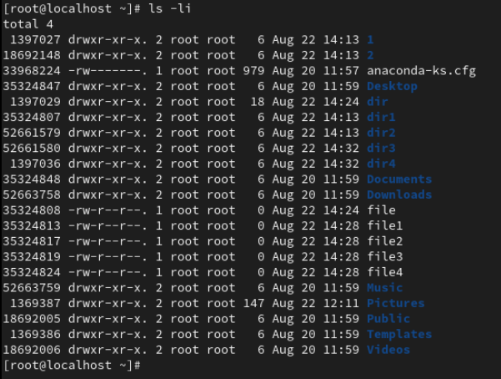

Display the content of file:
The cat command in Linux is used for displaying file contents.
Syntax:
#cat file_name
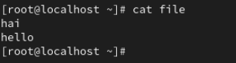
Show the details for commands:
The ”man” command in Linux is used to display the manual pages (short for "manual") for commands and utilities within the system.
Syntax:
#man ls
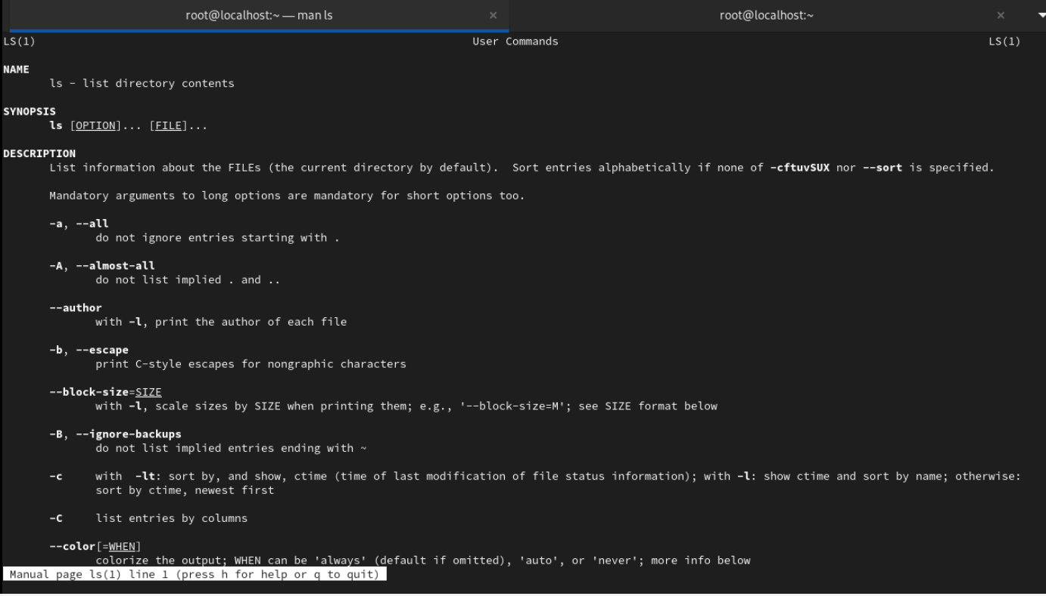
Switch to another account:
The su command in Linux, which stands for "switch user," is a fundamental utility used to change the current user account within a terminal session.
Syntax:
#su manju
If you also switch to another user account on your system, no need to put your password.
If you also switch to root account on your system, to provide your account password.
. Once switched, you remain as that user until you explicitly exit or log out and remember to logout the account.
Again go to the root directory from user directory:
Syntax:
#su -
In root account syntax is start with # symbol and the user account syntax is start with $.
Create parent directories:
The -p (or --parents) option in mkdir enables the creation of parent directories if they don't already exist.
Syntax:
mkdir -p 1st dir_name/2nd dir_name/3rd dir_name
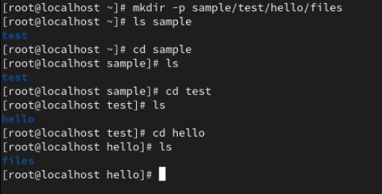
View the parent directories:
The tree command in Linux is a utility that displays the contents of directories in a hierarchical, tree-like format. It provides a visual representation of the file system structure, making it easier to understand the relationships between directories and files.
Syntax:
#tree dir_name
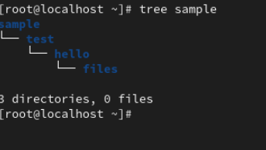

To Remove Directories:
The “rmdir” command is used to only remove empty directories.
Syntax:
#rmdir dir_name
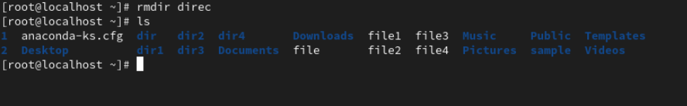
If you have one directory, this directory contains one or more files.You cannot delete this directory.
If you need to delete the directories and their contents, you can use ‘rm -r’ command.
Syntax:
#rm -r dir
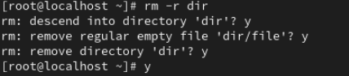
The rm -r command in Linux is used to delete directories and their contents recursively. This means that when you use rm -r, you are telling the system to remove not only the specified directory but also all the files and subdirectories it contains.
In this command to use , ask everytime yes or No to remove your directory and their contents.
If you want to forcefully remove your directory and their contents, you can use “rm -rf” command.
Syntax:
#rm -rf dir
Remove multiple directories:
If you want to delete the directories and their numerical numbers in their names, you can use the command in below.

Syntax:
#rmdir dir_name*
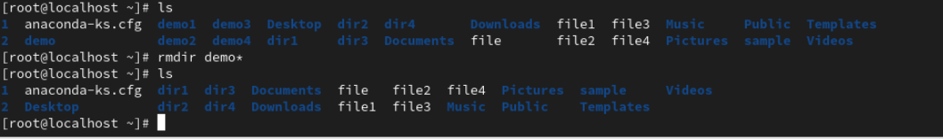
Remove directory with numerical sequence:
Syntax:
#rm -r dir*
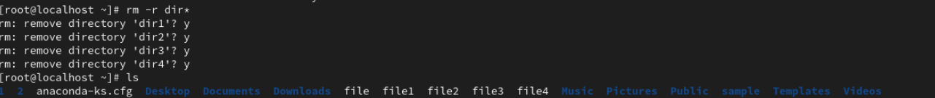
Syntax:
#rm -rf exmp*
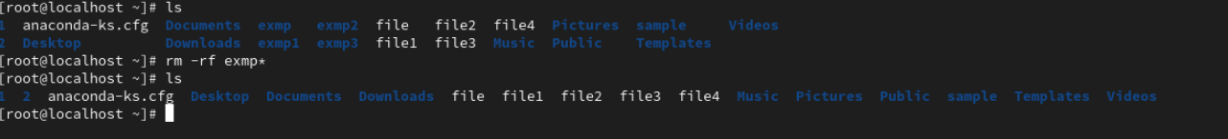
Delete files:
Syntax:
#rm -f file*
View&edit file:
Syntax:
#cat > test
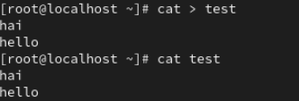

> symbol is used to ovverriding text.
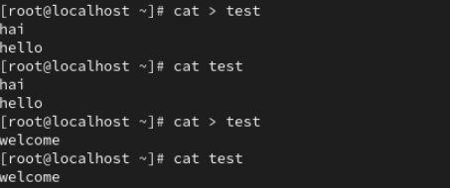
#cat >> test
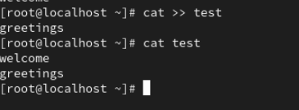

>> This append symbol is used to adding text in files.
Print Text:
Syntax:
#echo “hello”
If you print the text use “ “ or ‘ ‘ symbol.
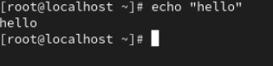
To add the text in files:
Syntax:
#echo “hello” > file
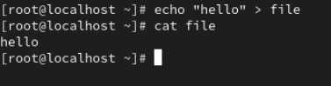
#echo “hai” >> file
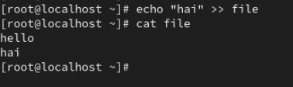
Print first 10 lines:
Display the beginning of first 10 lines.
Syntax:
#head file_name
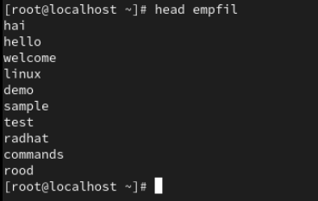
#head -12 file_name
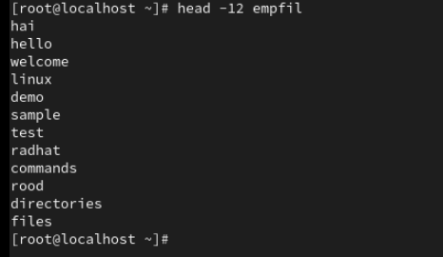
Print last some lines:
Display the end of last 10 lines.
Syntax:
#tail empfil
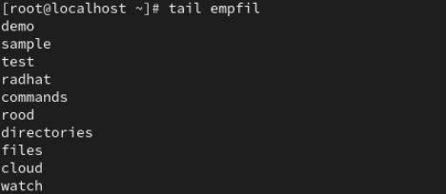

#tail -13 empfil
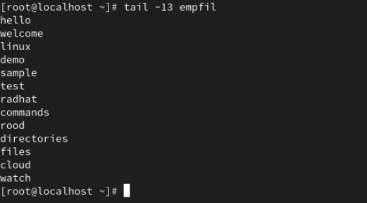
Less and more functions:
less command:
Purpose:
A more advanced pager than more, offering enhanced navigation and search capabilities.

Navigation:
- Allows both forward and backward movement.
- Use Up arrow or k to move up one line.
- Use Down arrow or j to move down one line.
- Press g to go to the beginning of the file.
- Press G to go to the end of the file.
- Press q to quit.
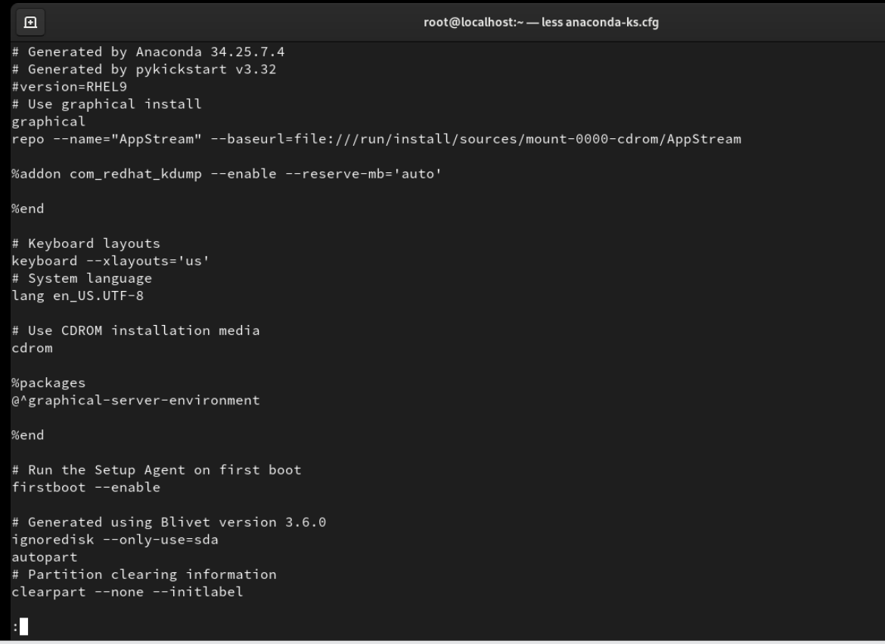

More command:
Purpose: Displays file content page by page.
Navigation: Primarily allows forward movement.
  - Press Spacebar to advance one page.
  - Press Enter to advance one line.
  - Press q to quit.
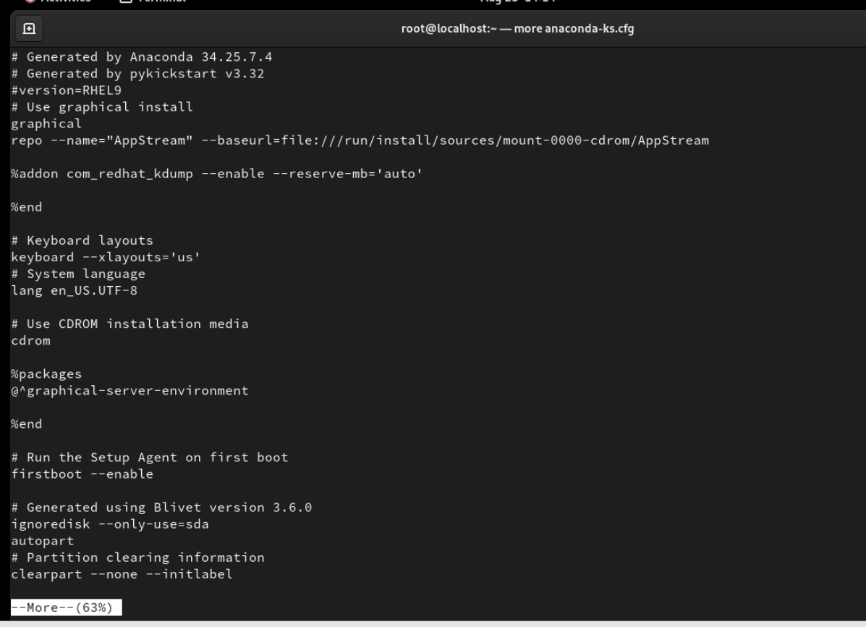
Absolute path:
An absolute path specifices the complete location of a file/directory starting from the root directory (/).
It always begins with a forward slash (/).
Syntax:
/home/manju/file/test
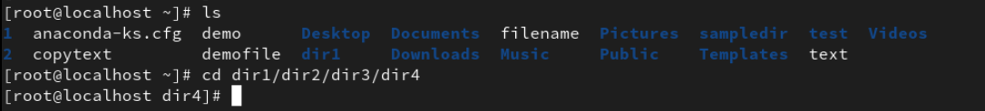
Relative path:
A relative path specifies the location of a file/directory in relation to the current working directory (the directory you are currently in).
It doesn’t start with (/) a forward slash.

Syntax:
cd dir3/dir4
To copy files:
The “cp” command is used to copy files and directories from one location to another location.( Push and pull is possible in cp command.)
It is a fundamental command for managing files within the file system.
Syntax:
cp source_name destination_name
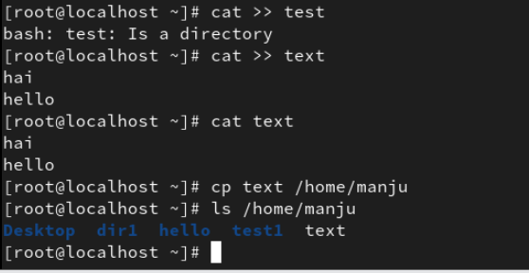
Copying multiple files:
Syntax:
cp file1 file2 destination_path
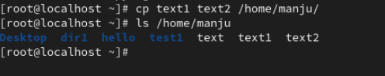
Copying directories recursively:
Syntax:
cp -r dir_name destination_path
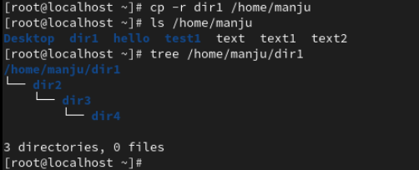
To pull the file from one path to another path:
Syntax:
cp source_path destination_path
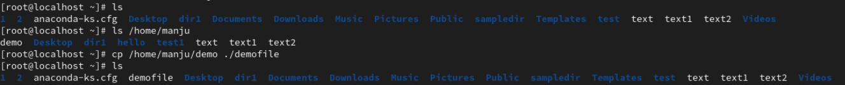

The demo file is renamed to demofile.
The . symbol is indicate root user.
To move the file:
The “mv” command is used for two purposes:
- Moving files/directories.
- Renaming files/directories.
- Moving files/directories:
To move a file/directory from one location to another location.
Syntax:
mv source destination
To moving file:
To moving directory:
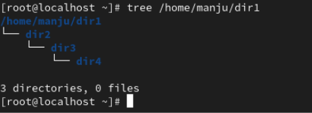
- Rename files/directories:
Rename file name:
Syntax:
mv old_name new_name
Rename directory name:
Clear command:
The “clear” command is used to clear the terminal screen.
It is removes all the previous output and commands from the terminal and providing a clean slate for further operation.
Uname:
The “uname” is an abbreviation for “UNIX name”.
When executed without any options, uname typically displays the kernal name. (e.g.Linux)
ifconfig:
An “ifconfig” command is used for display the information about IP addresses.
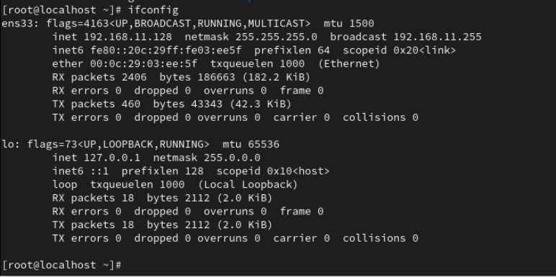
df -h:
The “df -h” command is useful when you want to see how much disk space is in use on particular partition and how much is left.
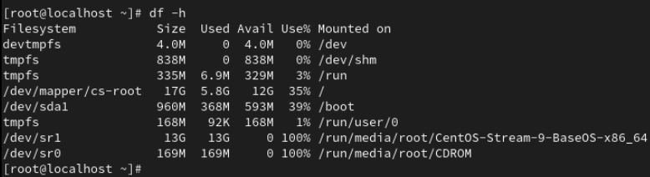
whoami:
This command is used to display the username of the current effective UserID (EUID) operating the shell or script.
